**INTEGRATION TESTING**

**IT_1: Customer Registration**

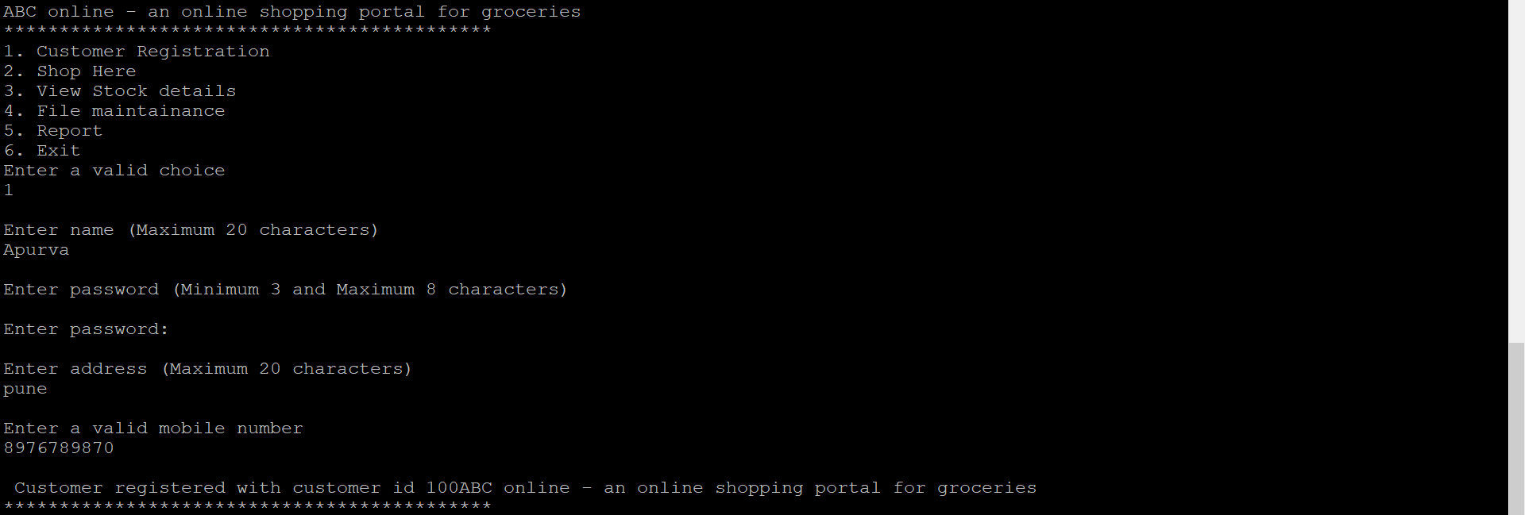

**IT_2: View Stock**

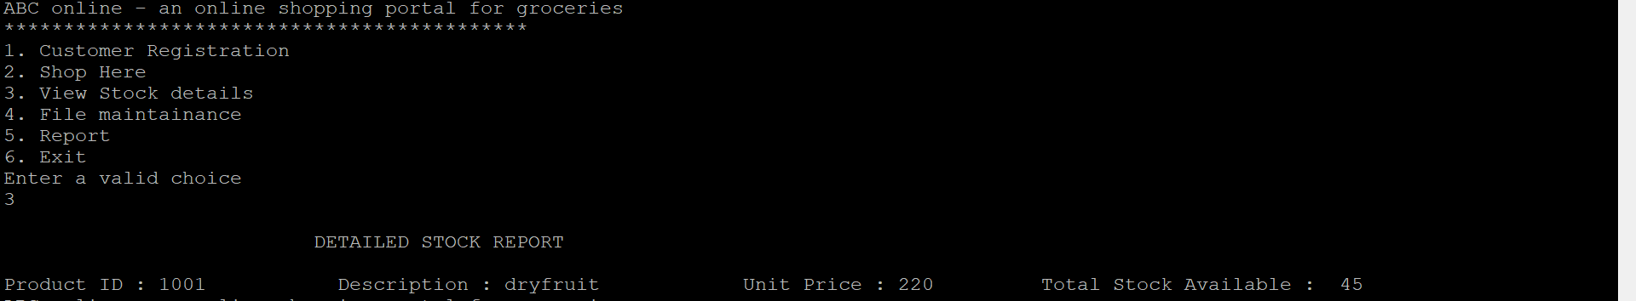

**IT_3: Edit Customer**

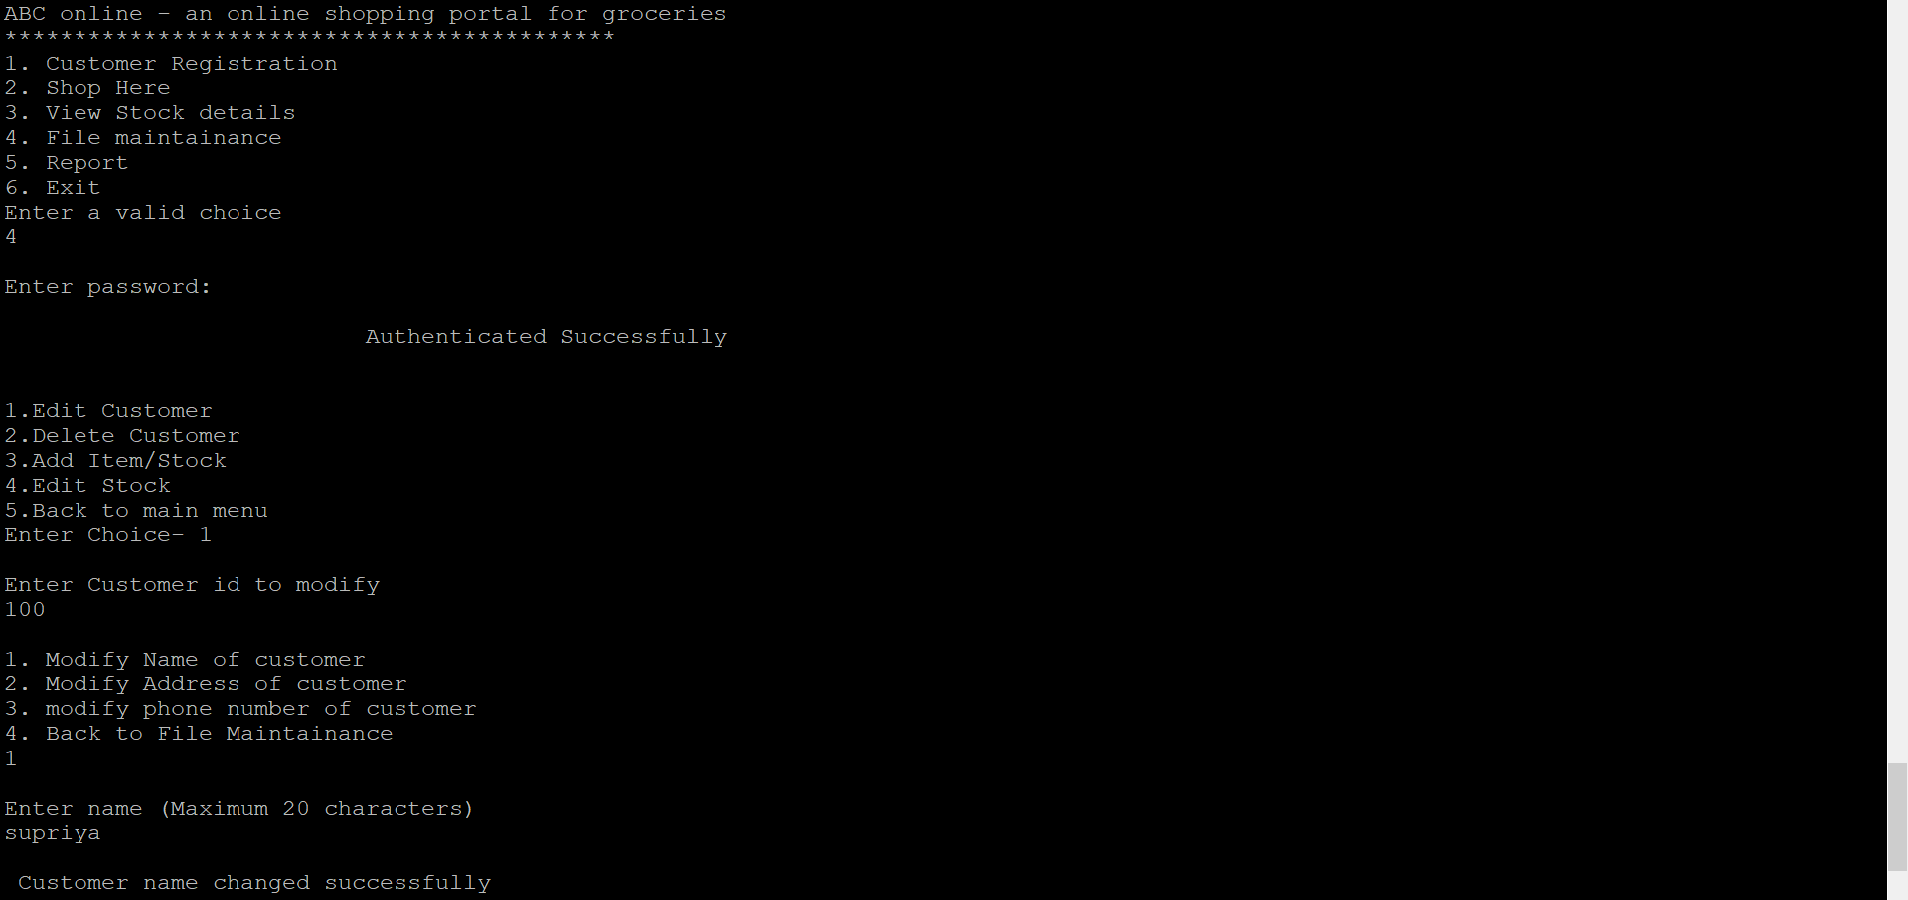

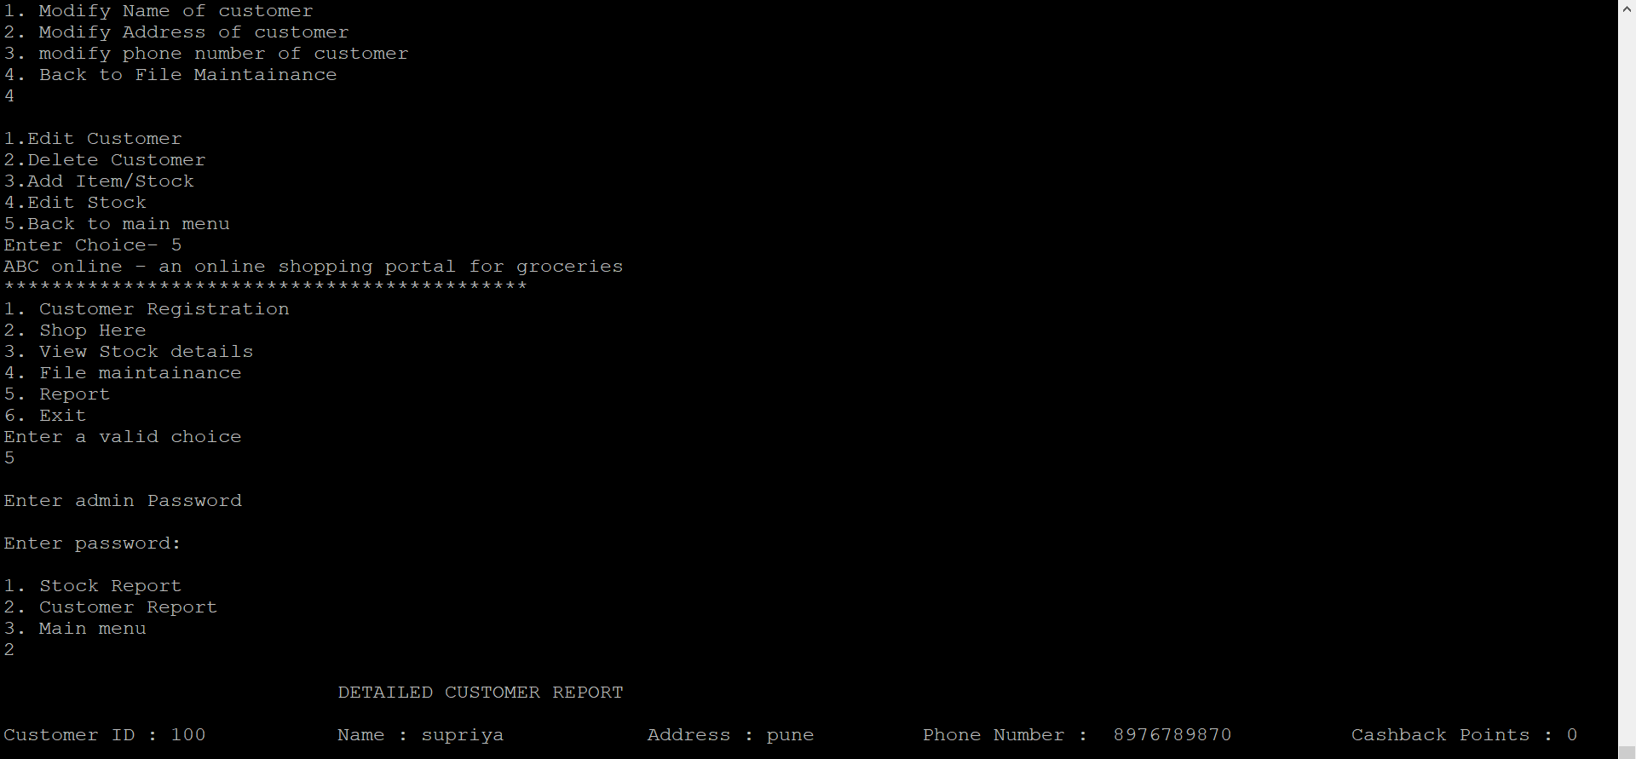

**IT_4: Delete Customer**

